Assignment 20.1:

Dataset link: Census_data_analysis_using_spark

Due to limitation of 22 elements for a map function, we are taking only 22 columns from the dataset

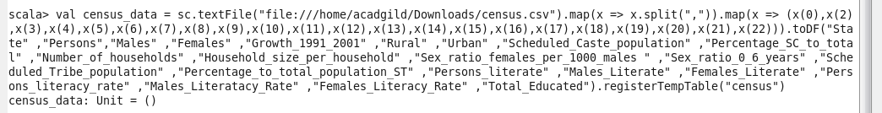

- Find out the state wise population and order by state:

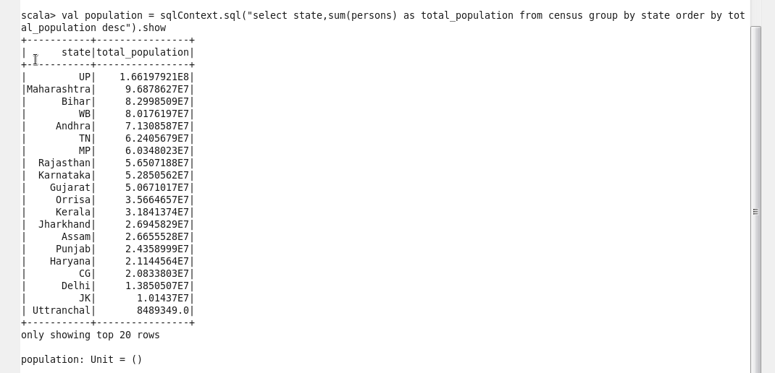

- Find out the Growth Rate of Each State between 1991-2001

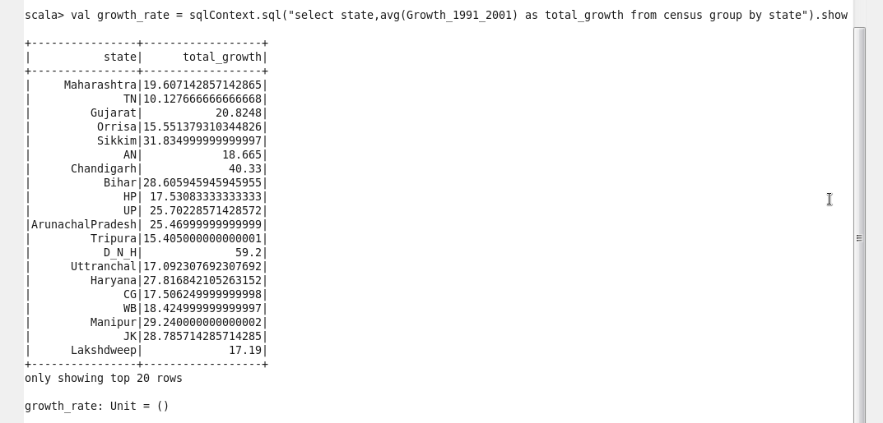

- Find the literacy rate of each state:

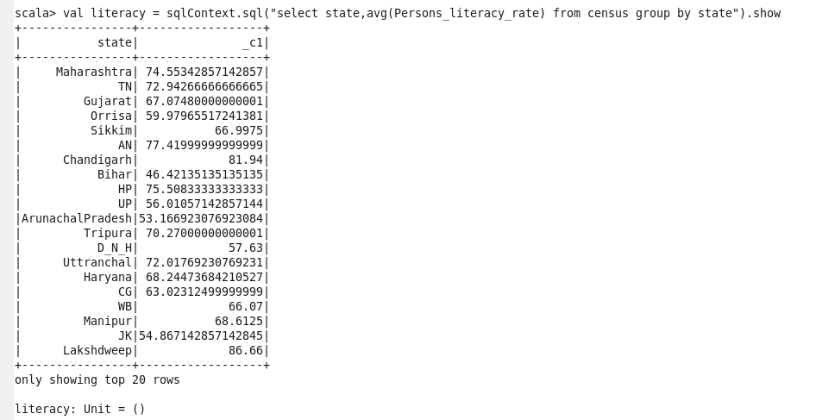

- Find out the states with more female population:

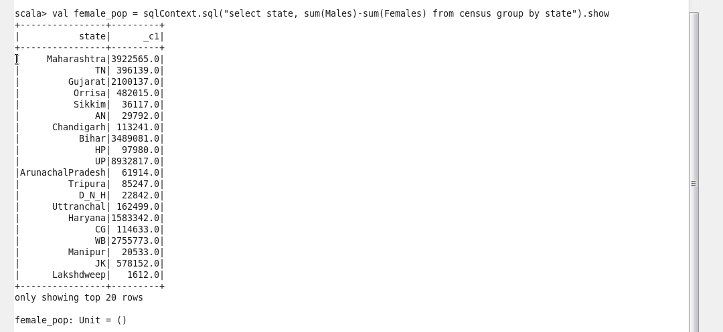

- Find out the percentage of population in every state:

